MANUAL

Research operation management system (ROMS)
Application for erfP
Principal Investigator (PI) Grant Application

[This document provides the necessary information for PI to navigate into ROMS when submitting the grant proposal for Education Research Funding Programme (ERFP) under Education Research Funding Programme Office (ERFPO)]
Restricted

Ver. 20230404

Table of Contents

1. USEFUL RESOURCES AND CONTACTS FOR GRANT APPLICATION ON ROMS 2
2. GENERAL INFORMATION ON ROMS 2
3. GRANT APPLICATION FORM FOR PRINCIPAL INVESTIGATOR (PI) 2
3.1. Grant Application Processes 2
3.1. Sign-in to ROMS 2
3.2. Principal Investigator (PI)’s Dashboard 3
3.3. Applying for a Grant 4
3.4. Filling out the Grant Application 4
3.4.1. Expression of Interest 5
3.4.1.1. Indication of Tier 6
3.4.1.2. Keywords 6
3.4.1.3. Submit 7
3.4.2. Section I. PROJECT OVERVIEW 7
3.4.2.1. Printable Application Form 9
3.4.2.2. Change ERFP Grant Category 10
3.4.3. Section II. PROJECT TEAM 11
3.4.3.1. Funded Research Undertaken by the PI in the last 5 years 11
3.4.4. Section II. PROJECT DETAILS 12
3.4.5 Section IV. BUDGET PLANNING 13
3.4.4.1. Integrity and Accuracy of Computation 14
3.4.5. Section V. DECLARATION 15
3.4.6. Full Proposal 16

USEFUL RESOURCES AND CONTACTS FOR GRANT APPLICATION ON ROMS

For general grants queries, please email Education Research Funding Programme Office (ERFPO) at grants@erfp.edu.sg.

For technical support on ROMS, please contact servicedesk@nie.edu.sg.

Please read the information on the grant call before applying. The grant call information can be found on the ERFP Website.

It is recommended that you submit your Expression Of Interest (EOI) in applying for the grant as early as possible. EOI submission is compulsory.

NOTE:

It is recommended to use the below browsers in accessing ROMS. You may experience a slight layout and functionality issue if another browser is used.

- Microsoft Edge
- Mozilla Firefox
- Google Chrome

GENERAL INFORMATION ON ROMS

Please review the document below to understand the basic field entry function of the system.

GRANT APPLICATION FORM FOR PRINCIPAL INVESTIGATOR (PI)

This section describes in detail how Principal Investigators (PIs) apply for Education Research Funding Programme (ERFP) grants online through ROMS.

Grant Application Processes

Before we go into details on the steps to apply for a grant, it would be beneficial to understand the grant application process. Below is a general workflow of ERFP grant applications.
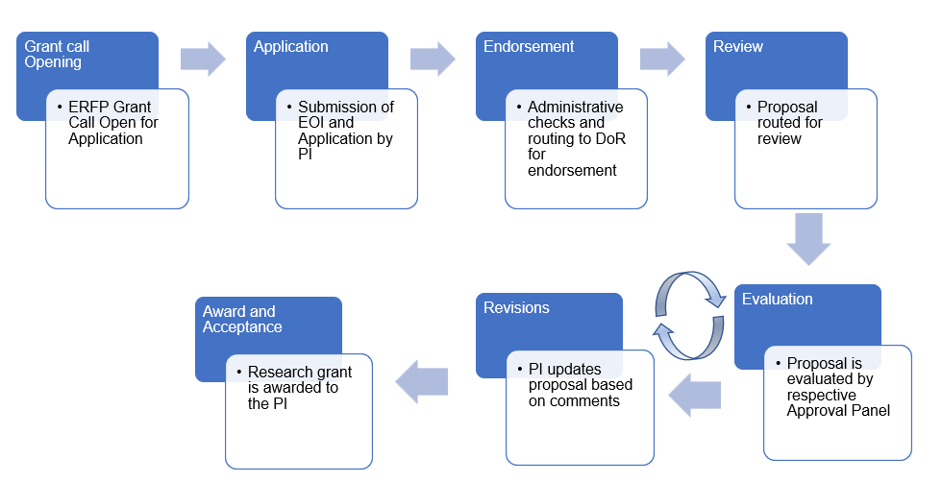

Sign-in to ROMS

To apply for ERFP grants, please go to ROMS at https://roms.nie.edu.sg.

For NIE applicant, please use your NIE account credentials to sign in to ROMS.

For other Institute of Higher Learning (IHL) applicant, please use the email address and password registered with ROMS through your IHL Point of Contact (IHL POC) to sign in.

Principal Investigator (PI)’s Dashboard

Once signed in, PI will be directed to their landing page which is termed as the Dashboard. The dashboard will consist of 3 to 4 sections in the form of the table depending on your role:

- Available Grants
This section indicates which grant is available for you to apply for.

- Forms Requiring My Actions
This section informs you that the application needs you to act on it.

- List of My Grant Application Forms
This section shows a historical record of all your applications plus the current application that is being processed.

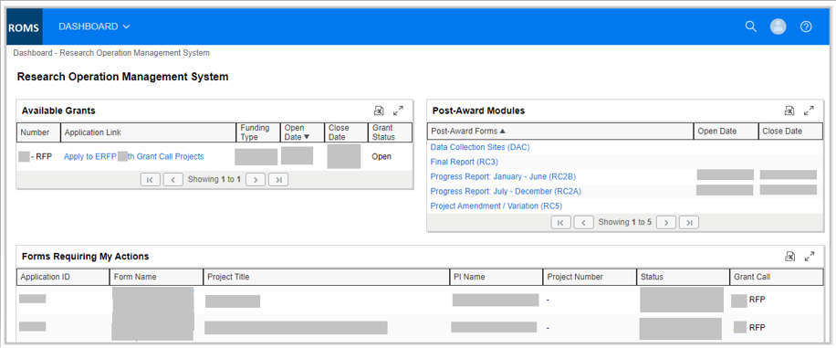

Note:
- To log out from the system, please click on the Sign Out link located on the top right hand of the system. This will be shown throughout the use of the system.

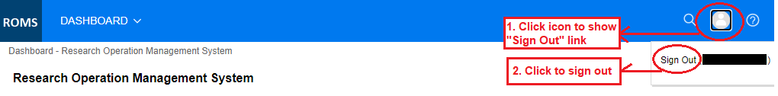

- All blue text in the dashboard is “clickable” and will direct you to the online forms.

Applying for a Grant

Go to the “Available Grants” portlet from your dashboard and click on “Apply to ERFP __ Grant Call Projects”.

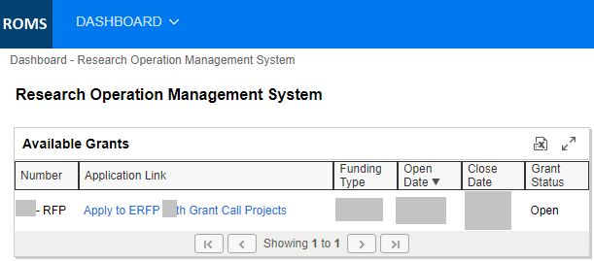

You will be directed to the application form as shown below:

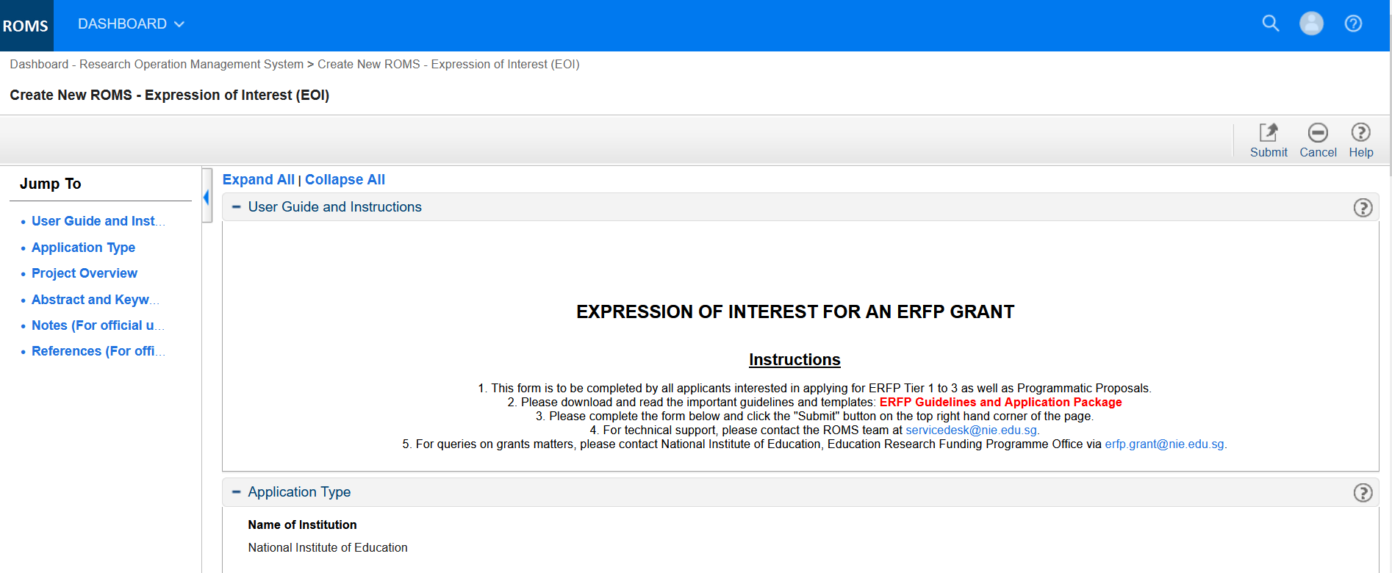

Filling out the Grant Application

5 compulsory sections must be completed in the Education Research Funding Programme (ERFP) grant application.

- Section I. Project Overview – Note that some fields in this section are keyed in during the Expression of Interest, as explained below.
- Section II. Project Team
- Section III. Project Details
- Section IV. Budget Planning
- Section V. Declaration

Each of these is visible as a set of tabs:

Also available in the tabs are:

- Change ERFP Grant Category – This allows you to change the grant category from Research to Development. To change the grant category to Programmatic Research, a new Expression of Interest (EOI) needs to be resubmitted.

- Full Proposal – This allows you to view and edit the entire application before submission.

Note:
- All sections in the application form have a User Guide and Instructions section. Please read the instruction carefully before filling out the form.

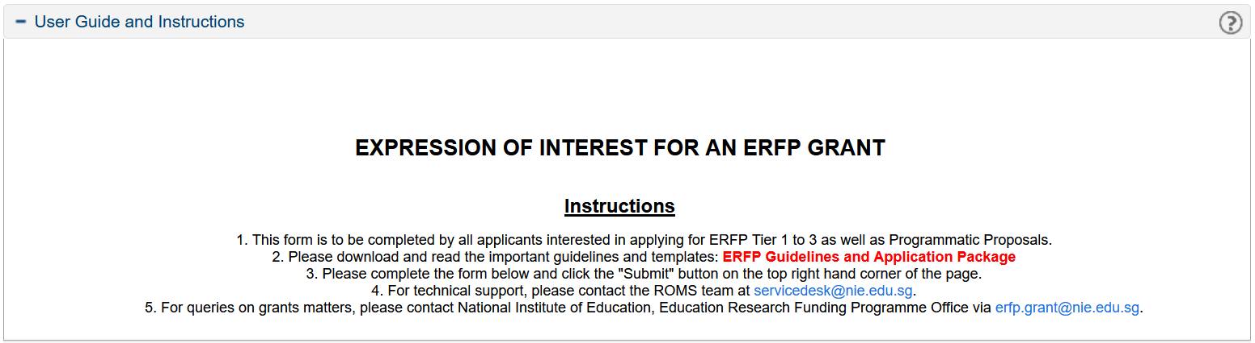

Expression of Interest

You must submit your Expression of Interest (see details below) first before filling up the rest of the application form. You can edit/modified your form after the Expression of Interest at any point in time and save them as a draft before submission. Do note that you will not be allowed to submit a research proposal without a prior Expression of Interest.

This section is the start of the application form. Before you can move on to the main sections of the application, you are required to fill in the Project Overview section and submit it as your Expression of Interest to apply for a grant. Filling out this section will indicate your intention to submit a proposal and a request /proposal identification (ID) will be generated. For any follow-up action, please use the request/proposal ID to identify your application to the administrative staff.

The purpose of this step is to notify the ERFPO of your Expression of Interest. It is recommended that you submit and record your Expression of Interest to apply for a grant in ROMS as early as possible. This will allow the ERFPO team to assist you in your application.

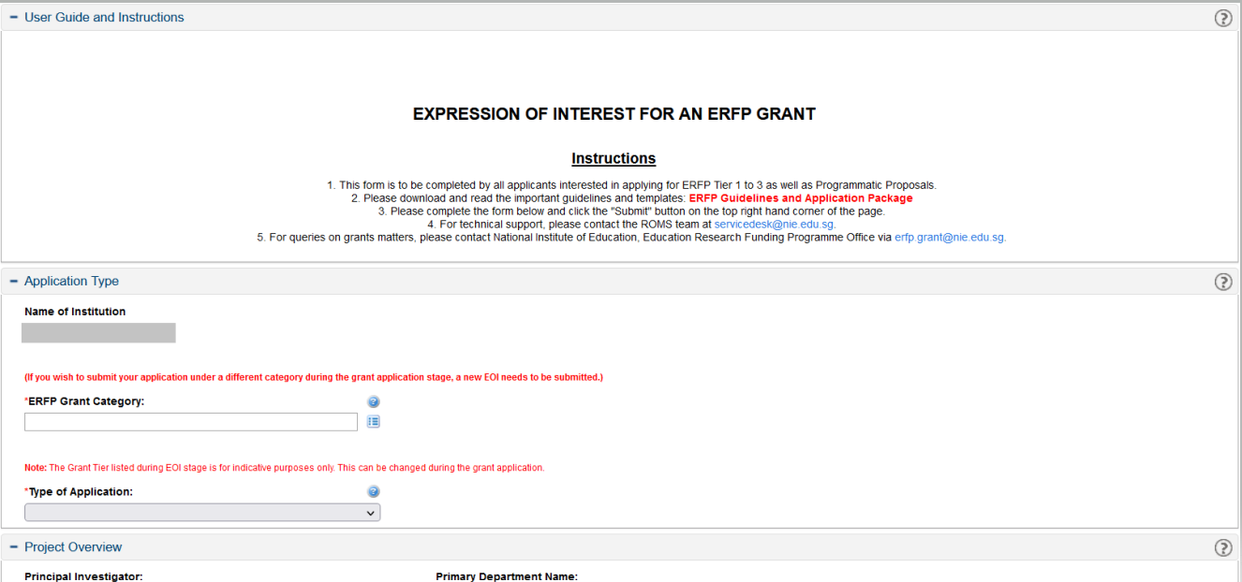

Note:

- The selection for Type of Application (‘new’ or ‘resubmission’) cannot be changed after submission of the Expression of Interest. The PI would need to resubmit a new Expression of Interest if the grant type changes.

Indication of Tier

The selection for Indication of Tier is mandatory for the EOI submission and is for indicative purposes only. This can be changed during the grant application.

      - Keywords

PI can choose 3 keywords from the selection list, with the 1st keyword selection mandatory. These keywords are based on the Education Resource Information Center (ERIC) thesaurus and identifiers. ERIC maintains a large-scale database that allows for indexing research across disciplines, themes, and most importantly, over time. These keywords are used by ERFPO to categorise PI’s study for reports and to support synthesis efforts. The keywords you use for publication and dissemination of your work (e.g. journal articles, book chapters, conference presentations) may be different.


To choose the keywords, please click on [] to select the keyword you would like to use.


PI can also write in 2 keywords of your own choice as descriptors for your study.

Submit

Once you have completed the Project Overview/Expression of Interest, please click on Submit button [] to express your interest.

Once submitted,
- An application ID will be created for your application. The application ID will be displayed.

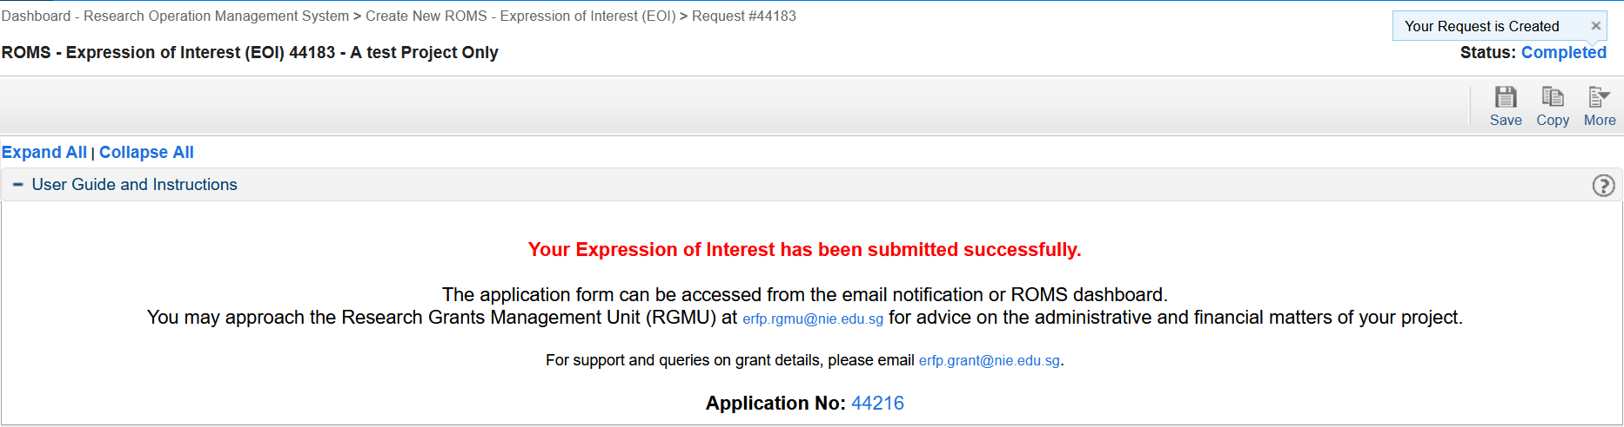

- An email will be sent to the grant owner and endorsing Reporting Officer, Director of Research (DoR) or equivalent that you have submitted an intention to apply for a grant

- You can continue to fill in your application. For NIE applicant, your delegated colleague could continue to assist in completing on behalf of you if you had assigned for an assistant (refer 3.4.1.2).

Note:
- Save your work every now and then by clicking [] on the upper right corner of the page.
- You can go back and forth between sections by using the available tabs above every page.

Section I. PROJECT OVERVIEW

This section is the start of the main section of the application form. Please fill in the necessary/additional information required in this section. Most fields have been keyed in during the Expression of Interest.

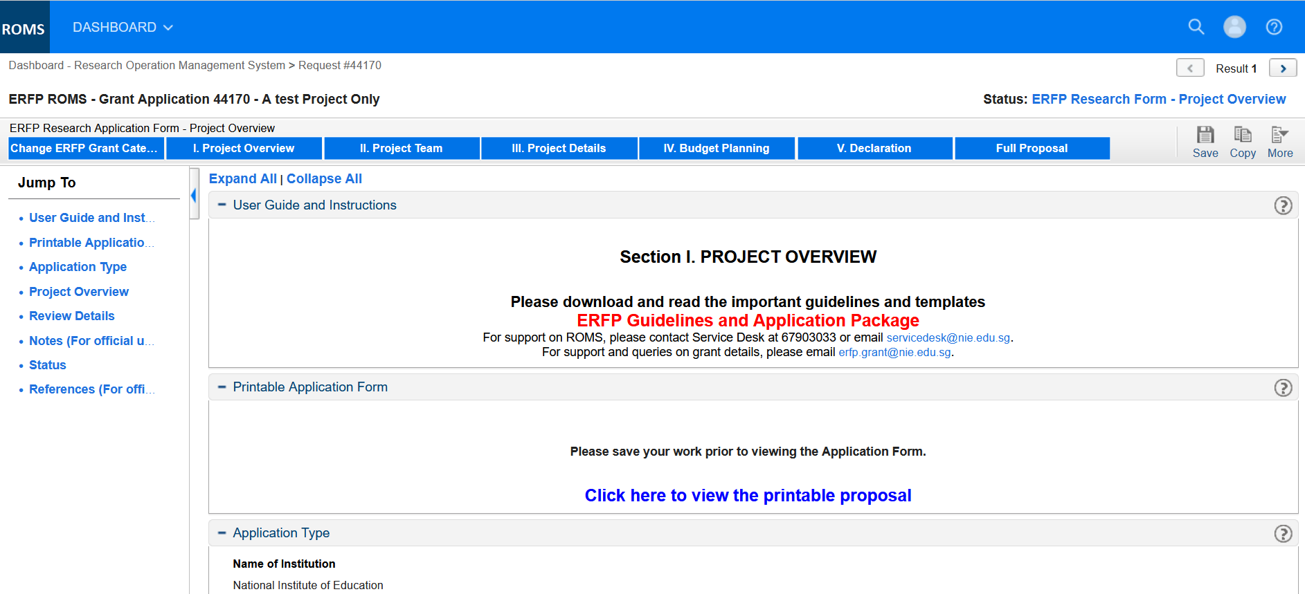

All fields that have [] icon next to it will allow you to select a single or multiple selection.

Single selection

Clicking on the [] will open up a dialogue box. You can scroll the list of available options and click on the text to select.

- If you know your selection, you can key in search text in the provided field. This will quickly narrow down your options.

- To view all your options again just clear your search text.

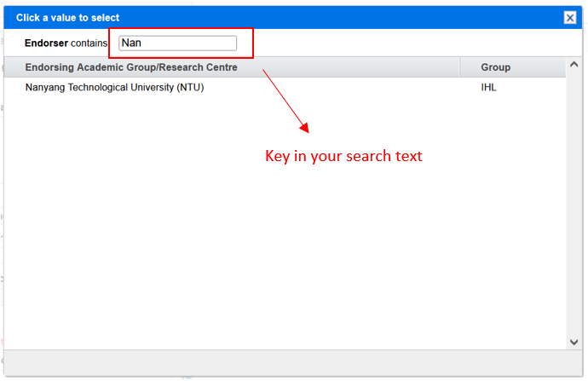

Multiple selections

- Click on the [] icon will open up a dialog box.

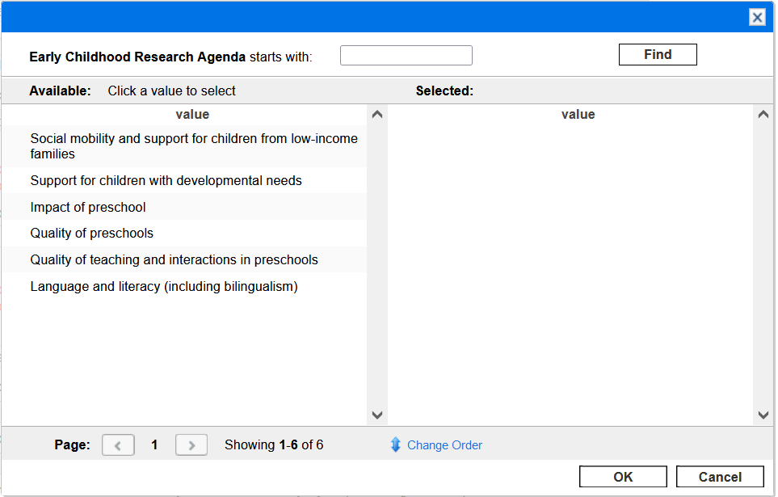

- Click the value to select from the Available list and the value will be changed to the Selected list. Proceed to click “OK” to save the selection.

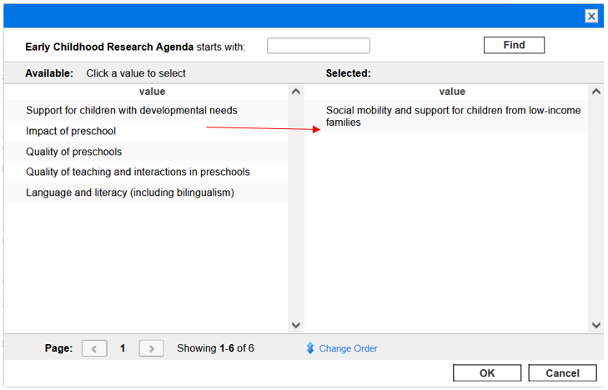

Printable Application Form

In the Printable Application Form section, you will be able to view the printable online form which has been customized for readability and will show the details of the entire application form.

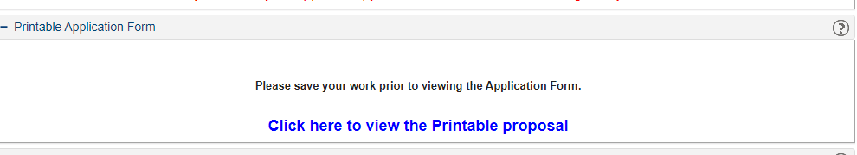

This Printable Application Form section is available throughout the application. The form will show the content that you have keyed into the system. For example, if you have keyed in just the Project Overview section, then only records in the Project Overview section will be populated to the printable online form. The rest of the other sections in the printable online form will be empty.

Note:
- Save your work now and then by clicking []on the upper right corner of the page.
- You can go back and forth between sections by using the available tabs above every page.

Change ERFP Grant Category

During the succeeding sections, until you have submitted your application, you have the option to change the ERFP Grant Category. To change the ERFP Grant Category from Research/Development to Programmatic Research, a new EOI form needs to be resubmitted. To do the change, you need to click [].

You’ll be directed to the following page:

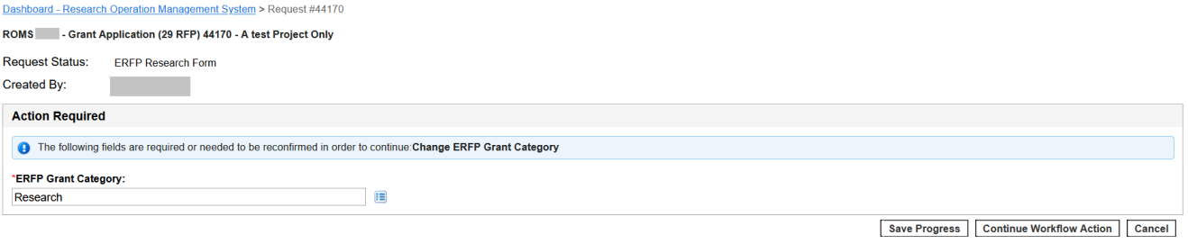
Change your ERFP Grant Category and click []. You will always be redirected back to the Project Overview section to confirm that the data/values still comply with the new ERFP Grant Category.

Note:
- Save your work now and then by clicking []on the upper right corner of the page.
- You can go back and forth between sections by using the available tabs above every page.

Section II. PROJECT TEAM

This section focuses on the project team that you will be proposing for your project. Add information on team members, the estimated hours of work per week on the project, their various roles, responsibilities and contributions to the project. Attach CVs.

This section consists of numerous table components. For the details on how to add a record to the table component, refer to Section 2 of this document.

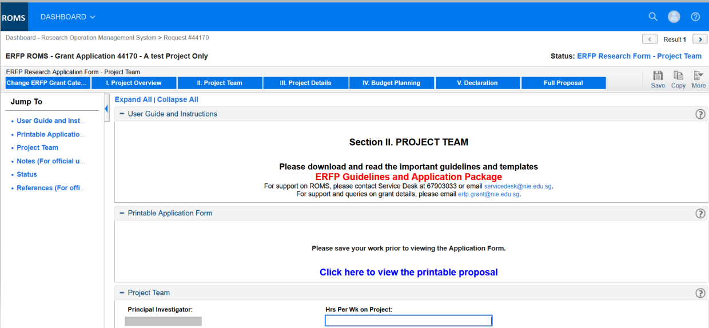

Funded Research Undertaken by the PI in the last 5 years

For all PIs, you will have to add in the Funded Research undertaken by you in the last 5 years. Please key in all columns including the Hrs Per Week on the Project column.

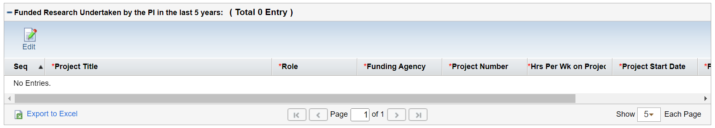

Hrs Per Wk on Project is referring to the number of hours undertaken by the PI during the course of the project.

For details on how to edit a record in the table component refer to Section 2 of this document.

Note:
- Save your work now and then by clicking []on the upper right corner of the page.
- You can go back and forth between sections by using the available tabs above every page.

Section II. PROJECT DETAILS

In this section, fill in project details such as the project abstract, research methodology, research questions, objectives, and deliverables.

For the details on how to add a record to the table component, refer to Section 2 of this document.

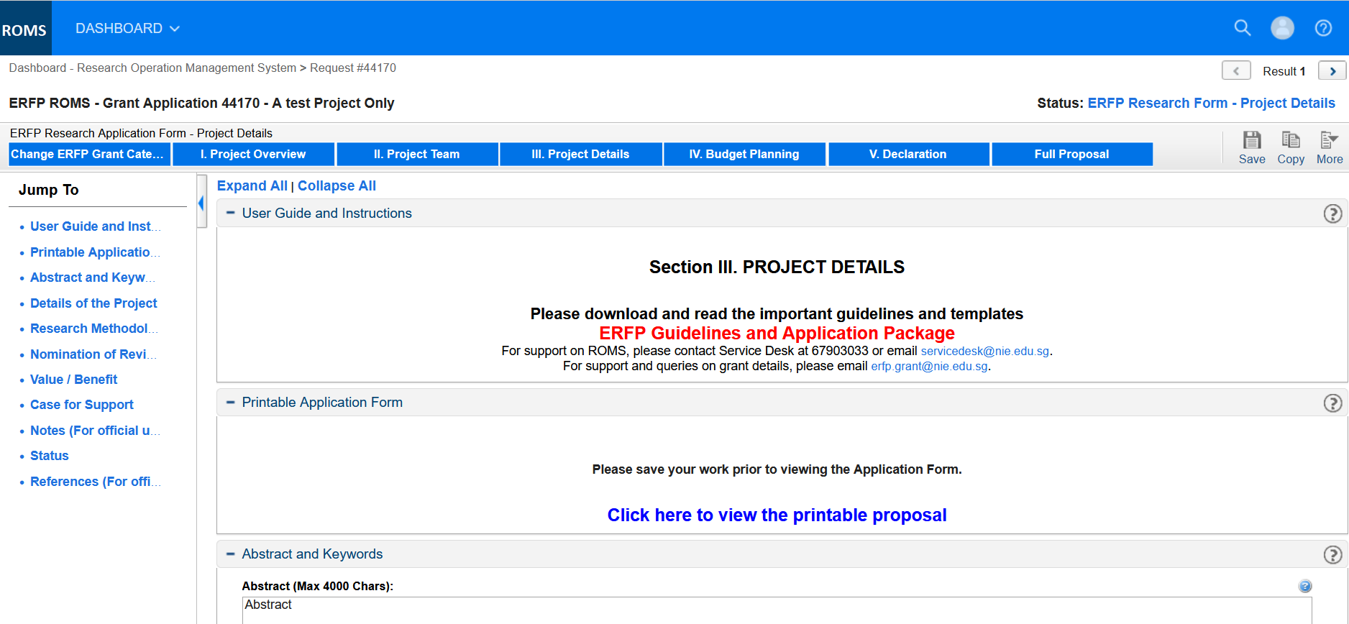

For the project abstract, provide a clear summary of the project purpose, methodology, and outcomes/deliverables. Ideally, the abstract will also show how the proposed project links with the identified research priority areas.

Keywords should be chosen carefully to reflect the theme of the project and to include crucial concepts/constructs which identify and distinguish your project in relation to other research. Be careful of keywords which are too general (e.g. ‘teachers’) and do not help to distinguish your research project. Ideally, keywords are echoed in your title and/or abstract.

3 keywords can be chosen from the drop-down menus and these keywords are based on the Education Resource Information Center (ERIC) thesaurus and identifiers. ERIC maintains a large-scale database that allows for indexing research across disciplines, themes, and, most importantly, over time. These keywords are used by ERFPO to categorise your study for ERFPO reports and to support synthesis efforts. The keywords you use for publication and dissemination of your work (e.g. journal articles, book chapters, conference presentations) may be different.

You can also write in 2 keywords of your own choice as descriptors for your study.

Note:
- Save your work now and then by clicking [] on the upper right corner of the page.
- You can go back and forth between sections by using the available tabs above every page.

Section IV. BUDGET PLANNING

This section records the budget that you require for the project. This is one of the most important sections of the application form. The total budget proposal for the application will determine the ‘tier’ of the project and the level of approval required for the application. This also impacts the requirements of the Case for Support.

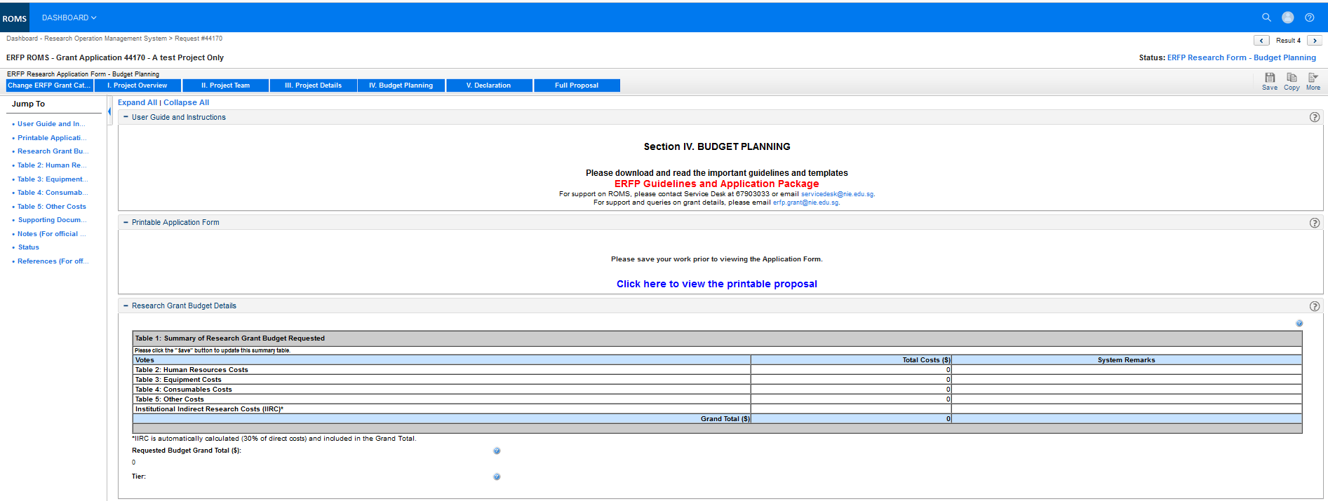

The budget for the project could consist of Human Resources Costs, Equipment Costs, Consumables Costs and Other Costs. There is an Institutional Indirect Research Costs which is 30% of the direct cost and is automatically calculated by the system and included in the Grand Total.

For details on what are allowable under the various type of expenses, you may refer to the online Help in ROMS.

For details on how to add a record to the table in the various costs, please refer to Section 2 of this document.

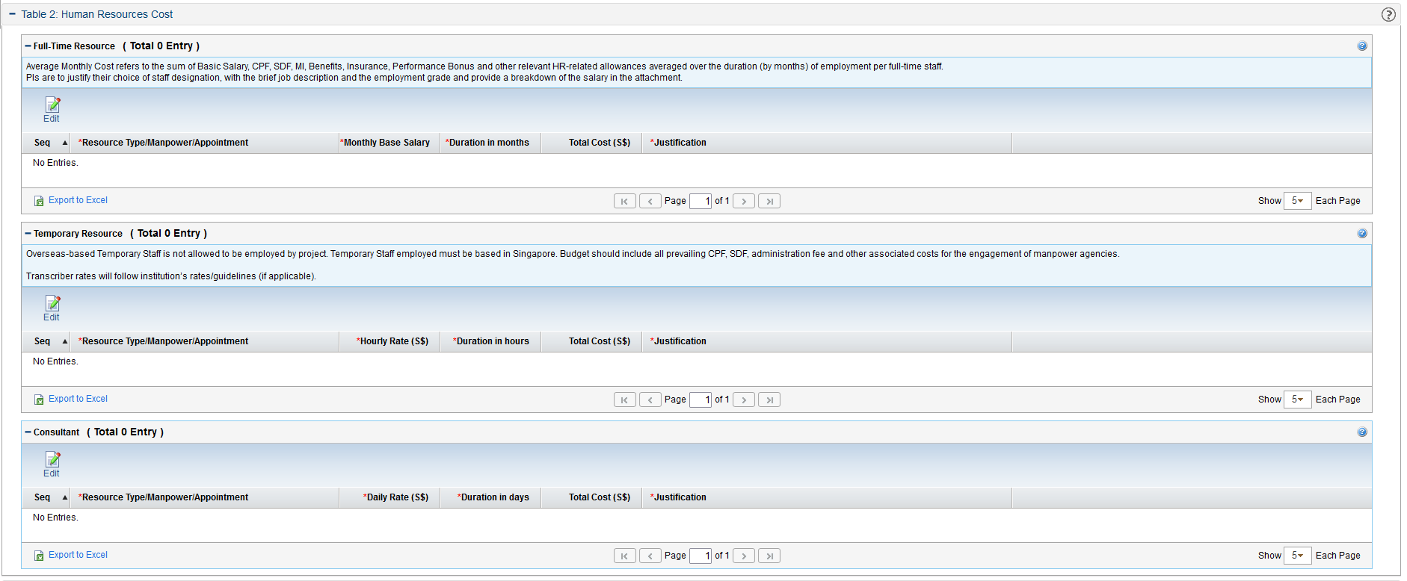
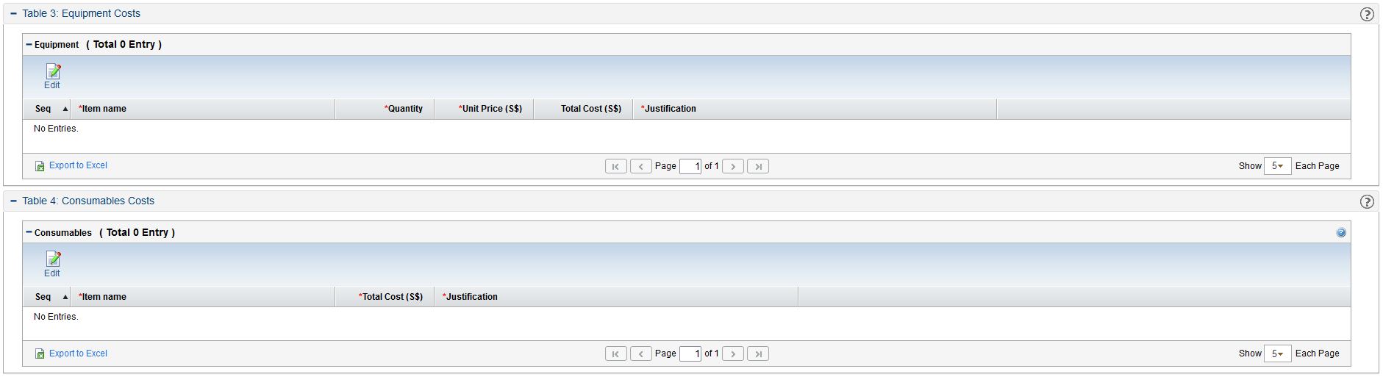
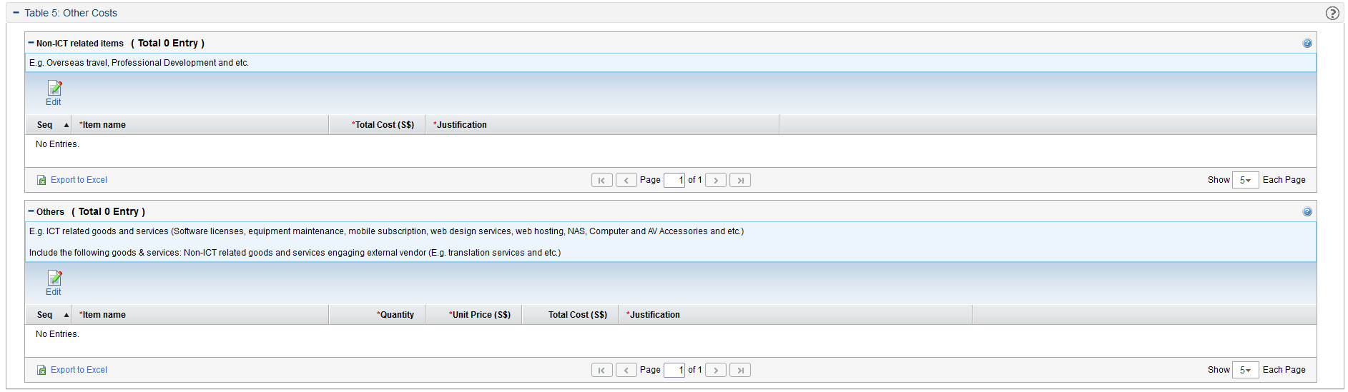

Integrity and Accuracy of Computation

Due to the complexity of the budget planning section, there is a function to caution applicants if their calculations have issues.

You can identify computation errors in Table 1: Summary of Research Grant Budget Requested as shown below. Note that the section will be updated only after you click on the [] button.

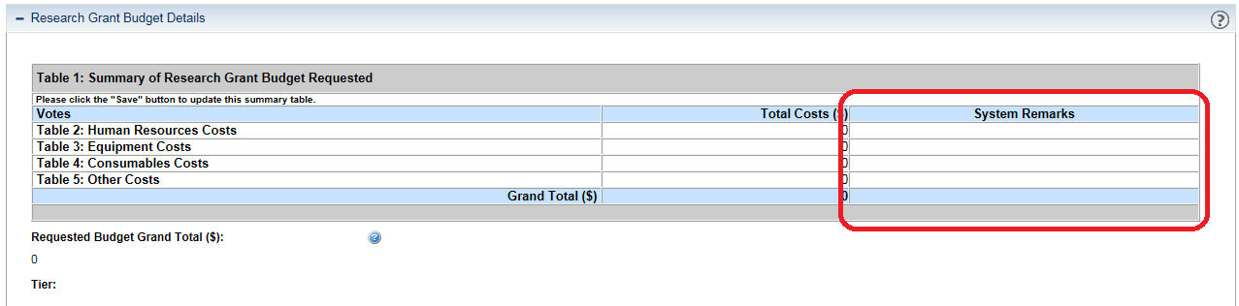

Note:
- Save your work now and then by clicking [] on the upper right corner of the page.
- You can go back and forth between sections by using the available tabs above every page.

Section V. DECLARATION

This section records your declaration for the Personal Data Protection Act (PDPA) and Undertaking Statements. Select the necessary options in the declaration and undertaking statements sections.

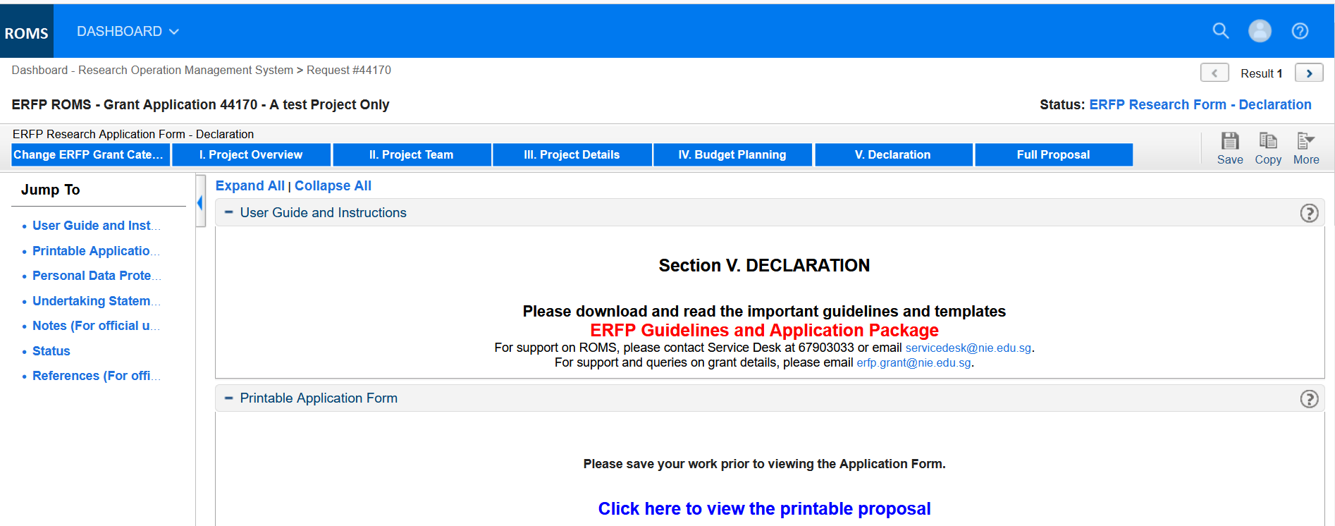
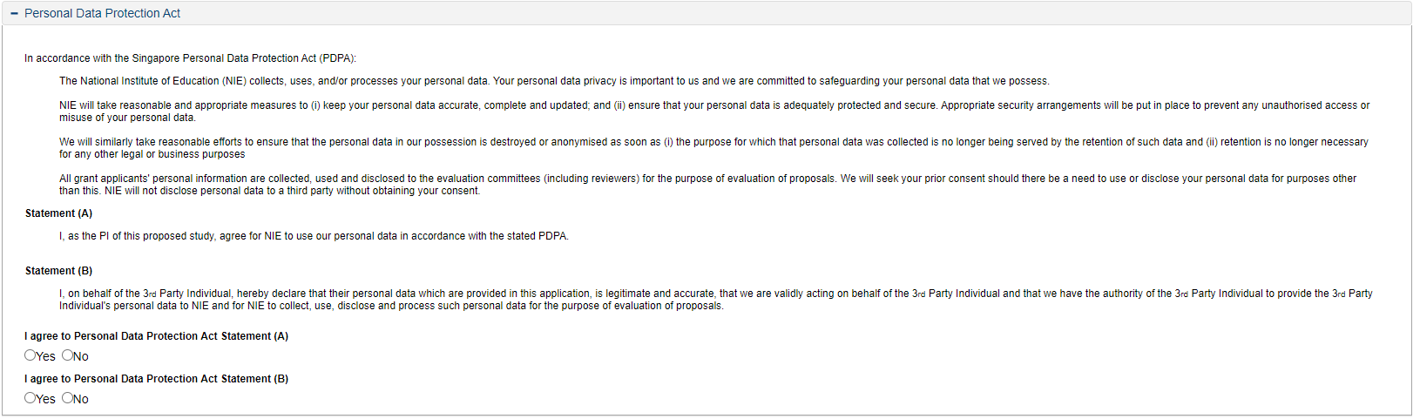
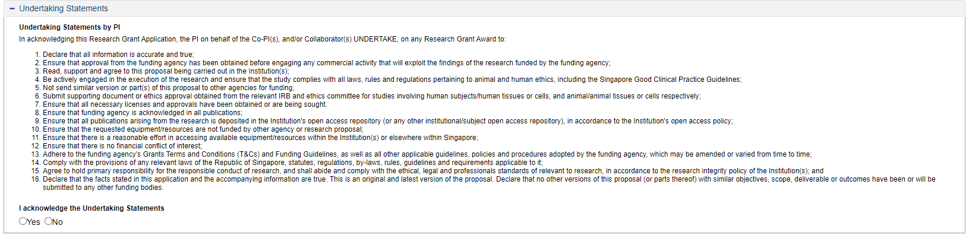
Note:
- Save your work now and then by clicking [] on the upper right corner of the page.
- You can go back and forth between sections by using the available tabs above every page.

Full Proposal

This is the final step before submission. This section allows you to view and edit the entire application before submission.

If you need to review the application section by section, please click on [] button. For submission, please click on [].

Note:
Once you submit your application, you will not be able to make changes to your documents.

In this section, a PI can only submit his/her proposal.

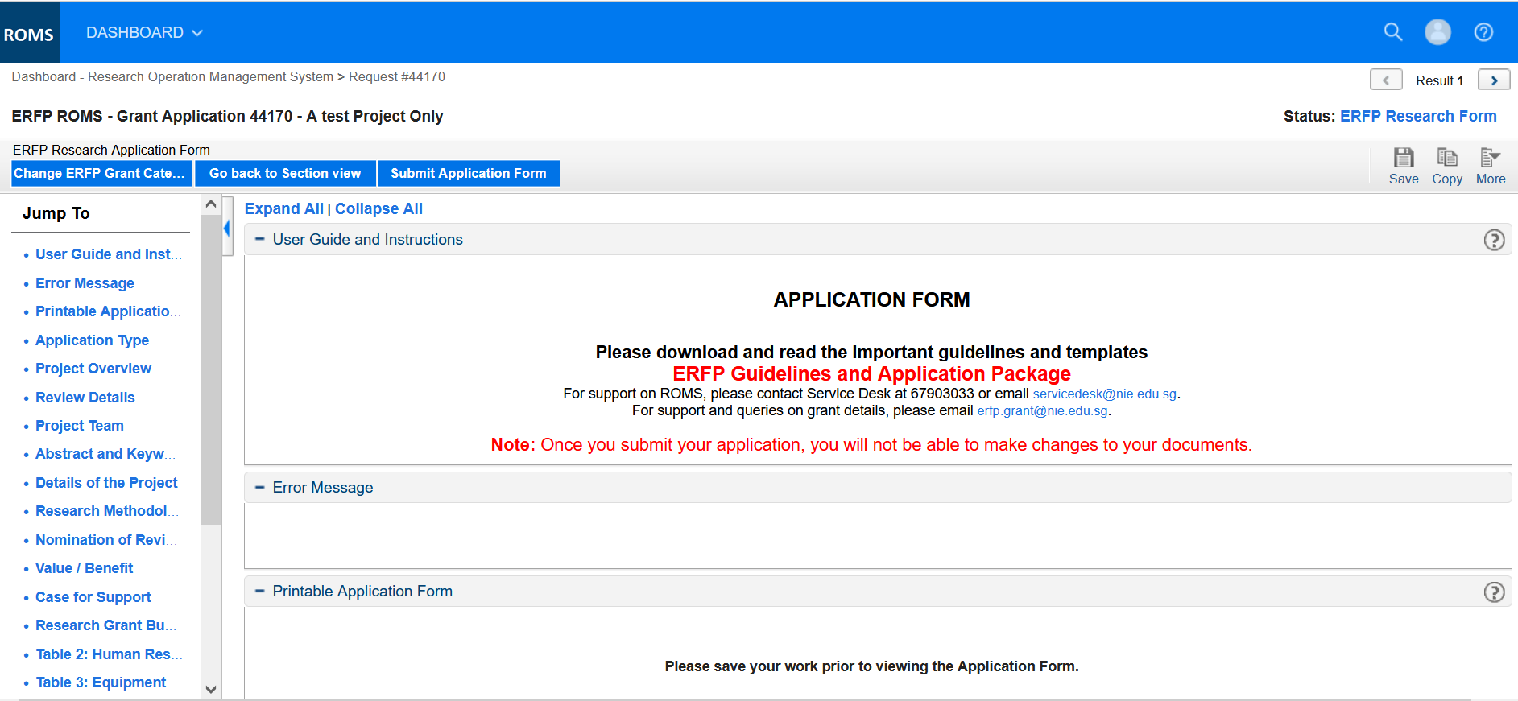

Complete your application by clicking the [] button.

Some error scenarios that you might encounter after clicking the [] button are:
- The reconfirmation page is an extra feature with which ROMS informs you that some required fields are not yet filled out. These fields should be filled to be able to submit your application successfully. Once you complete the missing field, click on the [] button on the lower right portion of the page.

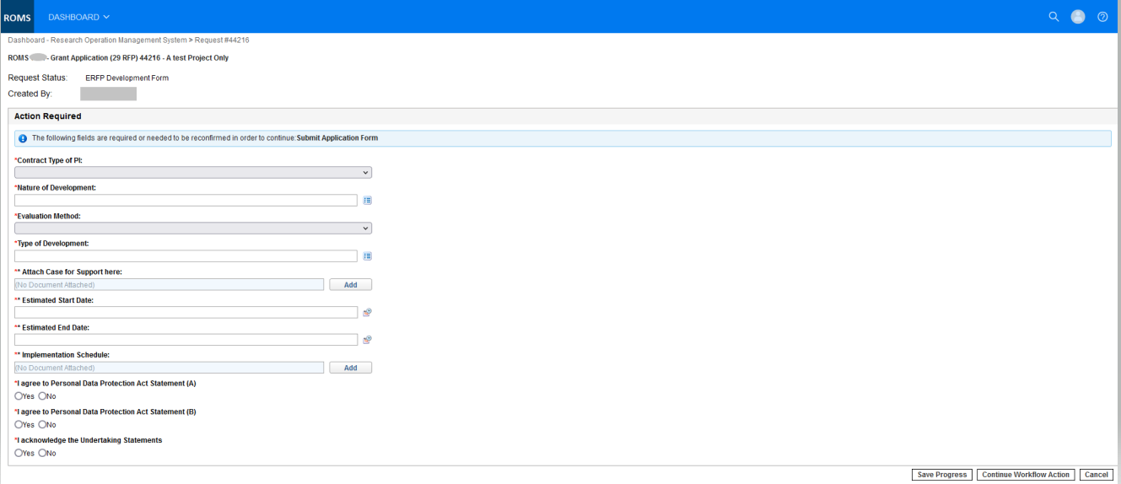

- Error wherein after submission you’ll be rerouted back to the application form with the following message as shown below. This is an additional ROMS system checking required by the committee. You must comply with every item before you can submit your proposal.

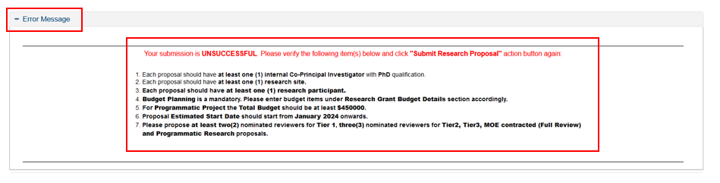

Once you have applied successfully, it will be forwarded to your Reporting Officer, Director of Research (DoR) or equivalent for endorsement.

Follow-up
The process described above is the first step in the grant application process. You may need to act upon your application in other steps of the process, e.g. ‘Evaluation’ and ‘Review’ (see section 3.1 – Grant Application Process).

You may be requested to update your proposal and if your proposal is approved, you will be required to put up an updated budget (‘budget phasing’) with details of your budget planning for ERFPO record purposes.

Your acceptance of the grant offer will also be through the system if your proposal is approved.

END OF MANUAL

